Lab Assignment – Data Visualization Exercise VI

Shaun Pritchard

Rasmussen College

QMB4100

Darice Corey

May 11, 2021

**Lab Assignment – Data Visualization Exercise VI**

For this analysis and wanted to determine a few factors based on the lifetime gross of films based on the genre category of movies over specific time. I chose this because I though it would be interesting in identifying trends of movie genres. This data could be used in industry and production to determine which movies would have more potential in the box office or earning in the market. We can see that since 1979 the rise and gross capital the movie industry has risen from 20 million to nearly 360 million using an area chart.

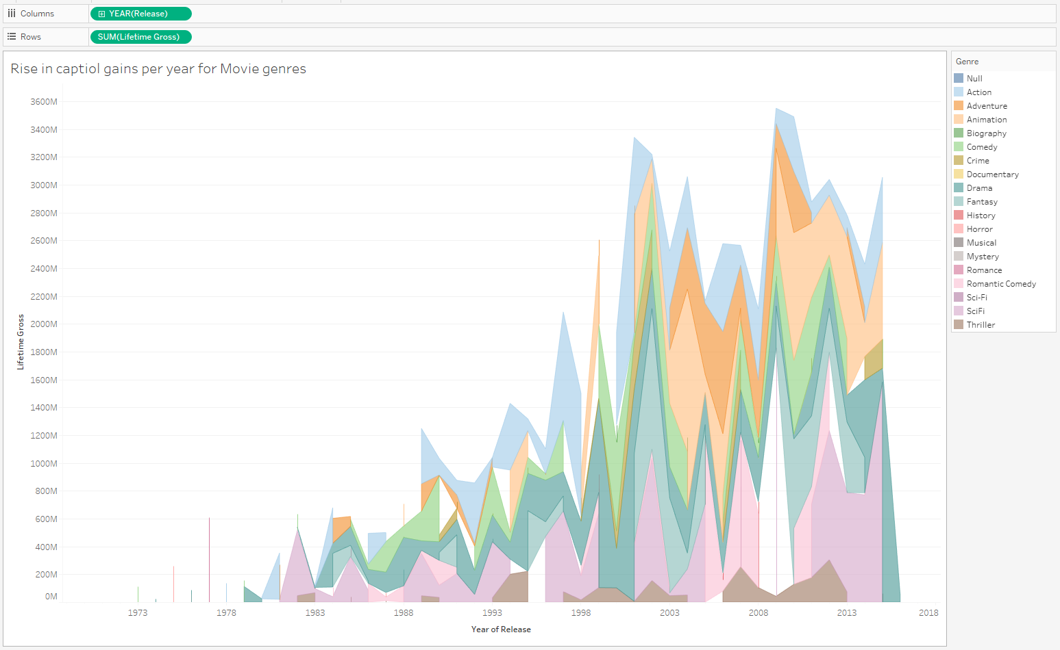

I then used custom calculated fields to determine the min and max genres that have risen to identify any trends using bar charts. We see that Sci-Fi started to rise in 2009 to 2015 but action and comedy where trends above the standard deviation from 1979 to 2008. The median average gross equals 464,729,630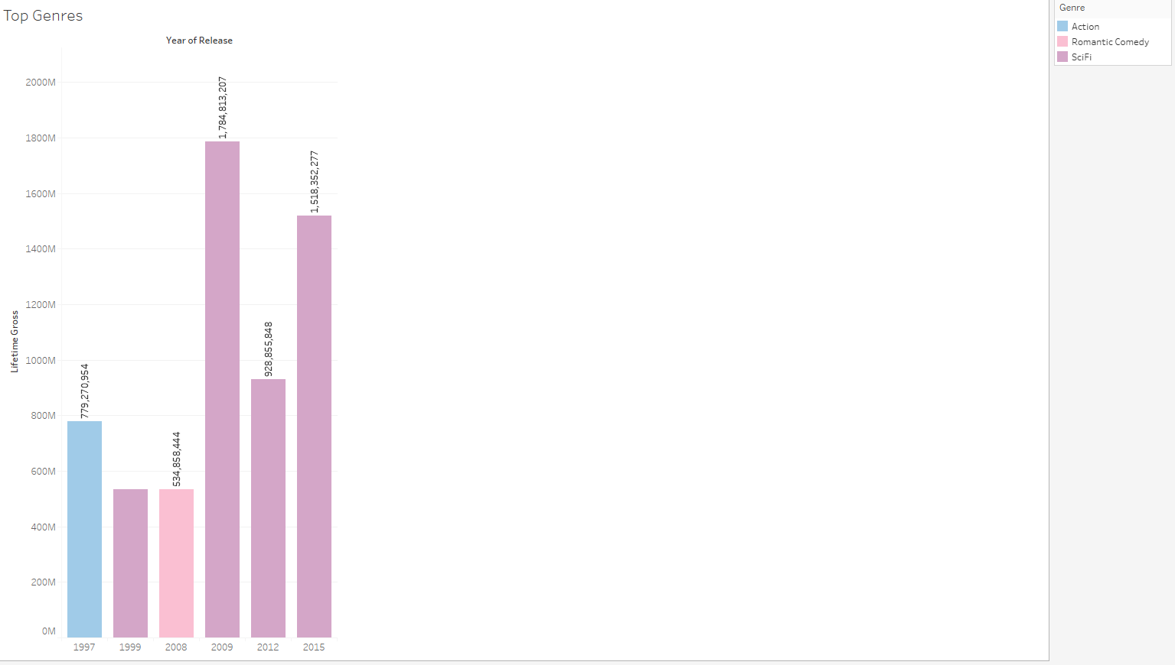

We can then see the overall performance of all 18 genres with Musical, Mystery, History, and Romance being the worst preforming.

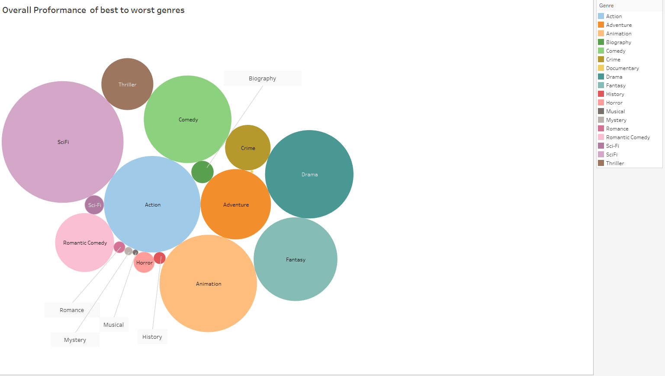

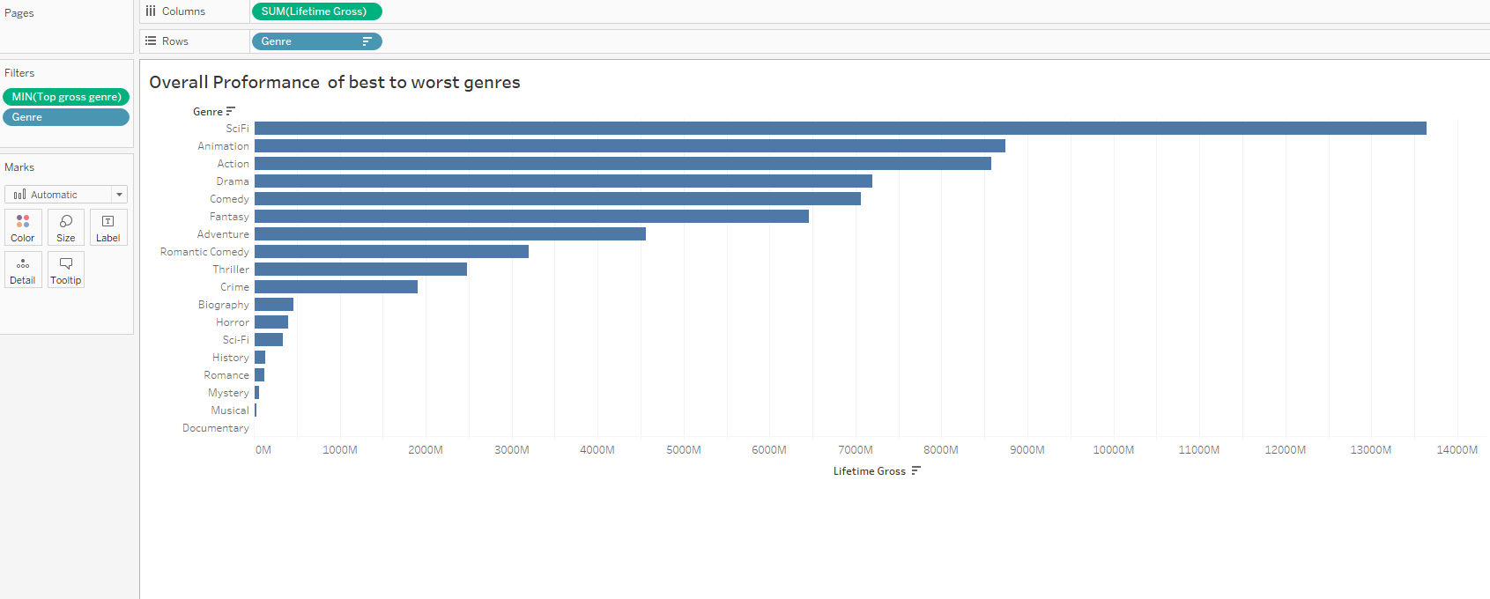

With data we can conclude that Sci-Fi would be a more profitable venture to invest in as well as Animation and Action. This data could be advantageous to determining trends in the movie industry. We can also determine that Sci-Fi preformed best in **2009** and **2015**. If we look at historical data and compare it to research we can see that in 2009 X men Origins movie was released followed by Iron Man 2 which was the beginning of the Marvel Franchise that is the highest growing movie franchise to exist. In 2015 Avengers 2nd movie was release with Ant-man and Fantastic four (CNBC, 2021) This could possibly explain these current trends.

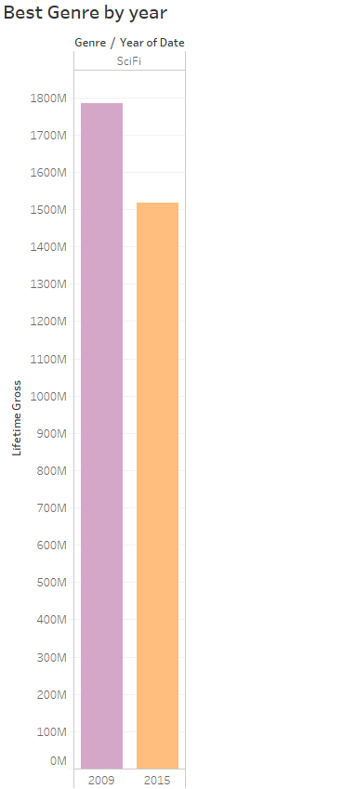

# References

CNBC. (2021, Jan 31). *The 13 highest-grossing film franchises at the box office*. Retrieved from https://www.cnbc.com: https://www.cnbc.com/2021/01/31/the-13-highest-grossing-film-franchises-at-the-box-office.html